Guide to Small Claims via Money Claims Online
Disclaimer
This guide is provided for general informational purposes only and is not legal advice. It is intended to give an overview of the Search Only Terms Contract: for Access and Use of Website (the “Contract”), but it does not replace or modify the Contract itself.
The Contract is the legally binding document governing access to and use of Website Content. In the event of any inconsistency between this guide and the Contract, the Contract shall prevail.
Application and enforcement of the Contract will depend on the specific circumstances of each case, including the nature of the Accessing Party, the method of access, and the relevant jurisdiction. Enforcement options, including litigation, may not be appropriate in all situations and should be considered on a case-by-case basis.
Publishers should seek independent legal advice where necessary, particularly in relation to implementation, enforcement strategy, and cross-border issues.
Nothing in this guide limits or waives any rights or remedies available to the Website Operator under the Contract or applicable law.
For the full terms, see the Contract.
(1) How do I bring a claim?
Short Answer:
The Contract provides a structured debt recovery process, including pre-action steps and the ability to issue claims in the County Court (including via Money Claim Online for smaller claims).
Longer explanation:
Under the Search Only Contract (“SOC”) we have set out a straightforward debt-recovery framework designed to enable publishers, particularly small publishers, to bring claims via Money Claim Online (“MCOL”). The SOC introduces an “Access Fee” for website access. All entrants to the website are subject to this fee regime. However, this Access Fee is expressly waived for licensed uses, comprising (1) search indexing and (2) personal, non-commercial use.
Those who enter the website for other uses are subject to the Access Fee. Under the terms and conditions, the payment of the entry fee does not mean that those who enter gain any rights to the content – those rights are expressly reserved for the Website Operator and can be protected separately.
Set out below is a framework for a simple debt claim that is to be brought via MCOL for claims that are less than 10,000 pounds in value. Even these claims can be pursued using a variety of procedural steps in the County Court and it is outside the scope of this note to explain all procedural rules.
Why MCOL?
The MCOL procedure is streamlined and designed to be accessible to litigants in person. Many aspects of the claim can be managed electronically through the online portal, providing a convenient and efficient process. This includes the submission of the claim form, acknowledgment of service and defence, payment of court fees, and the making of requests for default judgment where applicable. Parties may also use the portal to access the claim record and monitor the progress of proceedings.
Further, proceedings commenced via MCOL are issued through the Civil National Business Centre rather than a local County Court, providing a centralised digital route for issuing and administering claims.
Why the Small Claim track?
Cases at the County Court can be allocated in one of four tracks: small, fast, intermediate and multi. They each have their own rules that are designed to help resolve a dispute taking account of the value, nature and complexity of the claim being made.
By design, Small Claims have the most accessible rules so that claims can be brought and defended without the necessity of legal assistance. The benefits of being in Small Claims will be explained further below, though it’s worth stressing that one of the key advantages is that the costs of litigation are limited unless a party has acted unreasonably. This means that even if a Claimant loses the claim the Defendant is not usually entitled to their recoverable costs of the proceedings. Therefore, many of the procedures that apply to the other tracks are not applicable to Small Claims, as the process has been simplified.
The Small Claims procedure is designed for simple claims of a monetary value up to £10,000 (there are exceptions, but they are not material to SOC debt claims). If the claim is within the £10,000 limit, but the issues are otherwise “complex”, then it may be allocated to a different track of the County Court at the discretion of a District Judge. In this case we will endeavour to keep the claim to a simple debt recovery claim that is suitable for Small Claims and may be pursued using MCOL.
(2) Can I bring a claim via MCOL?
To bring a claim on the Small Claims Track via MCOL, as contemplated by the SOC, the value of the claim must not exceed £10,000 (see Civil Procedure Rules ("CPR") Part 27 and Practice Direction ("PD") 7C).
Where the aggregated value of the claim exceeds £10,000, proceedings must instead be issued in the County Court. Claims valued between £10,000 and £25,000 will ordinarily be allocated to the fast track, while claims exceeding £25,000 (and up to £100,000) will be allocated to the intermediate track. Anything above £100,000 will be allocated to the Multi-track.
Eligibility to use MCOL is also subject to jurisdictional and procedural requirements. In particular, the address for service must be in England or Wales. As a result, MCOL may not be the appropriate route where the defendant is outside the jurisdiction, as claims can only be brought where the defendant’s address for service is within England and Wales. In addition, MCOL claims are restricted to a maximum of two claimants and two defendants.
Identifying the Correct Defendant
It is important to identify the correct defendant at the outset. If it later emerges that the claim has been brought against the wrong party, the claim may fail, requiring the proceedings to be discontinued and resulting in the loss of the court fee.
Depending on the systems you have in place, it may be possible to identify the crawler responsible for scraping your content, for example through server logs or other logging data.
However, even where the crawler can be identified, it may not always be possible to identify the correct defendant with certainty, particularly within multinational corporate groups where responsibility is divided between entities in a manner that is not readily apparent. In those circumstances, it is important to demonstrate to the court that you have taken all reasonable steps to ascertain the correct party. One way of doing so is to include the following wording in your Letter Before Claim:
“If you are not the entity responsible for the alleged acts described in this letter, please notify [me/us] as soon as reasonably practicable and, so far as you are able, identify the entity responsible. Failing such notification, [I/we] will proceed on the basis that the Company is the responsible entity. If it subsequently transpires that the Company is not the correct defendant, we reserve the right to seek recovery of any resulting costs, including on the indemnity basis.”
List of Potential Defendants
Based on our experience, please find below an updated table with potential defendants and their addresses.
The list below is not intended to be exhaustive. Claims have not been brought against all of the defendants identified below. Please ensure that you undertake your own reasonable enquiries and verification before relying on this information.

Company | Address | UK Company Number (if applicable) | Crawlers often associated with the Company
Amazon.com, Inc. | 410 Terry Avenue North  Seattle  Washington 98109 | N/A | Amazonbot  Amzn-SearchBot  Amzn-User
Apple Inc.  Apple (UK) Limited | One Apple Park Way  Cupertino  California 95014  280 Bishopsgate  London  United Kingdom  EC2M 4AG | N/A  01591116 | Applebot  Applebot-Extended
Google LLC (Google Search provider to users based in UK) | 1600 Amphitheatre Parkway  Mountain View  California 94043 | N/A | Googlebot  Google-Extended  Google-CloudVertexBot
Meta Platforms, Inc. | Legal Department  1 Meta Way  Menlo Park, CA 94025  United States of America | N/A | Meta-WebIndexer  Meta-ExternalAds  Meta-ExternalAgent  Meta-External Fetcher  FacebookBot
Microsoft Ireland Operations  Limited | One Microsoft Place, South  County Business Park, Leopardstown, Dublin 18, D18 P521, Ireland | N/A | N/A
ByteDance Limited  ByteDance Technology Co., Limited | 43 N 3rd Ring W Road  Beijing  China  71-75 Shelton Street  Covent Garden  London  United Kingdom  WC2H 9JQ | N/A  16182979 | Bytespider
SpaceXAI LLC | 800 W Cesar Chavez St., Austin, TX 78701, USA | N/A – Nevada registered company
OpenAI, Inc.  OpenAI UK Limited | 3180 18th Street  Suite 100  San Francisco  California 94110  Suite 1, 7th Floor, 50 Broadway  London  United Kingdom  SW1H 0BL | N/A  14367667 | OAI-SearchBot  OAI-AdsBot  GPTBot  ChatGPT-User
Anthropic PBC  Anthropic Limited | 548 Market Street  San Francisco  California 94104  9th Floor, 107 Cheapside  London  United Kingdom  EC2V 6DN | N/A  14604577 | ClaudeBot  Claude-Web  Claude-User  Claude-SearchBot  anthropic-ai
Perplexity AI, Inc.  Perplexity AI Limited | Suite 900, 115 Sansome Street  San Francisco  California 94105  C/O Cogency Global (UK) Limited 6 Lloyds Avenue, Unit 4cl  London  United Kingdom  EC3N 3AX | 15470377 | PerplexityBot  Perplexity-User
Cohere, Inc.  Cohere UK, Limited | Suite 200, 171 John Street  Toronto  Ontario  Canada  4th Floor, 51 Great Marlborough Street  London  United Kingdom  W1F 7JT | N/A  13987418 | cohere-ai
Yandex LLC | 16 Leo Tolstoy Street  Moscow  Russia | N/A | YandexBot  YandexAdditional  YandexAdditionalBot
Webz.Io, Inc. | 7 Metsada Street  Bnei Brak 5126112  Israel | N/A | omgili  omgilibot
AlphaAI Technologies Inc. d/b/a Tavily | 1350 Broadway  24th Floor  New York, NY  10018  USA | N/A
SideGuide Technologies, Inc. d/b/a Firecrawl | 800 Haight Street  San Francisco, CA  94117  USA | N/A
Bright Data | 4 Hamachsev St.  Netanya  Israel  4250714 | N/A
Brave Software, Inc. | 48 2nd St, Floor 3  San Francisco, CA  94105  USA | N/A
Linkup Technologies | 28 Avenue des Pépinières  94260 Fresnes  Paris  France | N/A
SerpApi, LLC | 1632 S 1st St.  Austin, TX  78704  USA | N/A
Parallel Web Systems Inc. | 2261 Market Street  #5578  San Francisco, CA  94114  USA | N/A
SuSea, Inc. d/b/a You.com | 228 Hamilton Ave  Floor 3  Palo Alto, CA  94301  USA | N/A

What do I do if the Defendant is not a Company registered in England and Wales?
MCOL (Money Claims Online) may only be used where the Defendant's address for service is within England and Wales. Where a Defendant does not have a registered address or a served address within England and Wales, MCOL is not available and proceedings must be issued using a paper claim form at the County Court specified above in this document.
Claimants should identify the appropriate defendant entity, preferably a UK-incorporated entity where one exists, before issuing proceedings. If proceedings must be brought against a foreign company, service outside the jurisdiction may require the court's permission under CPR Part 6 Section IV. Such applications are significantly more involved than a standard MCOL claim, requiring detailed evidence, including a witness statement giving a full and balanced overview of the claim in accordance with the applicant's duties on a without-notice application. In addition, service in certain jurisdictions, such as China, can be particularly lengthy and procedurally complex, resulting in increased legal costs and delays.

Evidence Gathering
Before commencing the pre-action process, it is important to gather and organise evidence demonstrating that Access Events occurred, that one or more Products were accessed outside the permitted licence, and that the resulting contractual sums are due. The evidential model under the Contract is intended to be practical and does not require proof of internal processes (such as AI training). Instead, it relies on a combination of technical records, publicly available materials, and reasonable inference based on consistent patterns of access and reuse.
At a minimum, a basic claim should include the following core evidence, organised clearly (for example, in tabbed form):
- Screenshot from Wayback Machine dated [date of Contract integration in Website’s robots.txt file]
- Search Only Terms Contract for Access and Use of Website [version] dated [date of version]
- [Website Name] Terms and Conditions dated [insert]
- Letter notifying the [Company] of the Contract’s implementation, the Access Fee and its amount (using the pro-forma here: https://m4ow.uk/socw/Pro%20Forma%20Notification%20Letter.docx)
- Invoices [insert name and date of invoice(s)]
- Server logs or other logging data showing the Access Event took place
- Screenshot of the Product as shown on the Website on [insert date]
- Screenshot of response/output dated [insert date]
- Email from [insert your name] to [insert company name] notifying the Company of its obligation to pay, dated [insert date]
- Evidence that the Company refused to pay the invoices (only where applicable)
- Additional Evidence related to the Unlicensed Access Event (optional, where available)

Server Logs

Whilst evidence of the Website Content appearing in AI outputs can show downstream use of the content, experience has shown that more needs to be done to prove which bot did the scraping and when it happened.
This is especially important in light of the new SOC implementation strategy, which requires that the Defendant is aware of both the SOC and the Website Operator’s own website terms and conditions by way of notification in the form of a letter to the AI companies.
This means that, where possible, you should obtain server logs for your site showing the crawler/bot’s identifiers, which would demonstrate that a crawler has accessed a given page at a given time.
Evidence collected should be focused, proportionate, and clearly linked to specific Products and Access Events. In practice, a small number of strong, clearly documented examples are likely to be more effective than large volumes of complex or ambiguous technical data.
If website logs are unavailable, the appearance of the Website Content in AI outputs may be relied upon as evidence that the content was scraped – however, you cannot be certain whether the content was scraped by the company providing the output itself, or whether that company merely bought the scraped content from a third-party reseller. Thus, you should invoice the visible AI company, and make an explicit request for any records of their purchase of the scraped content (if they did not scrape the content themselves) in the Letter Before Claim (see below).
Check Implementation

At this stage, you should also verify that the contract has been properly implemented by ensuring that:
- It has been correctly incorporated into your Website Terms and Conditions in accordance with the FAQs;
- The relevant lines have been correctly implemented in your website’s robots.txt file; and
- The relevant company has been notified of the contract's implementation and the applicable access fee, including the amount you have selected.
Failure to properly complete any of the above steps may undermine the effectiveness of the contract and may mean that the other party was not provided with adequate notice of its existence.
Invoices
Invoices form a key part of the claim and should be prepared carefully. As a minimum, each invoice should: (i) be issued in the correct legal name of the claimant (e.g. the company bringing the claim); (ii) clearly identify the recipient (the Accessing Party); (iii) be dated; (iv) include a unique invoice number; (v) specify the number of Products accessed and the corresponding Access Fees; (vi) set out the total amount due; and (vii) include any applicable VAT or tax information. The invoice should clearly link the sums claimed to the contractual basis for the charge. These invoices will form the foundation of the debt claim and should be consistent with the evidence relied upon.
(3) Pre Action
Bringing a Claim against an Individual
The Pre-Action Protocol for Debt Claims ('the Debt Protocol') applies where a business (including a sole trader or public body) is claiming a debt from an individual (including a sole trader). Non-compliance with the relevant protocol may result in cost sanctions at the court's discretion.
Under the Debt Protocol, the Letter of Claim must be in the prescribed form and must enclose specific documents, including: (1) an Information Sheet; (2) a Reply Form; and (3) a Financial Statement form. The Defendant must be given at least 30 days to respond. These requirements are mandatory where the Debt Protocol applies.
Bringing a Claim against a Company
Where the Defendant is a company or other incorporated entity rather than an individual, the Debt Protocol does not strictly apply; however, the court will still expect the parties to have acted reasonably and in the spirit of pre-action correspondence (see CPR r.44.2 and the Practice Direction on Pre-Action Conduct and Protocols). In either case, non-compliance with the relevant protocol may result in cost sanctions at the court's discretion.
In this case it is advisable to follow the general Practice Direction – Pre-Action Conduct And Protocols (the “Pre-Action Protocol”). The Defendant will need to be given at least 14 days to reply and up to 3 months where the claim is particularly complex.
Sending a Letter Before Claim
There are certain protocols that have been designed to inform a potential defendant, at an early stage, of the basis of the claim, the claim’s value and the reasons why it is being contemplated against them. Such an early notification is set out in the Letter Before Claim, which enables the Defendant to consider the claim, and either admit it or set forth any reasons why they should not be held responsible for it at an early stage. In that way, any matters in dispute can be crystallized or settled before involving the court.
To begin the process, it is advisable that an invoice(s) is/are sent to the potential defendant for the amounts that are owed under the SOC. This will form the basis for the total amount due for the Letter Before Claim, and later for the Particulars of Claim/Statement of Case that will be filed with the Small Claims court if the claim is not settled at the Letter Before Claim stage.
For each claim there are certain facts that will be required before the Letter Before Claim can be finalised and sent. You, as the Claimant, will need to know: Who the Defendant(s) is/are; what they have done; and why it is that you have a claim against them. You may also wish to consider what information/documents you might require from the defendant to finalise your claim – this could include, for example, server log evidence of their crawler/bot accessing your website.
If you can determine from the SOC the final amount that is owing to you, and therefore can calculate any interest that is to be recovered, then you will be able to pursue the claim using the MCOL procedure.
A draft Letter Before Claim particularising a debt claim is appended to this note. You will need to input the relevant information including any documentation (e.g. your site’s Terms and Conditions and the Invoice(s)) that you are relying upon in support of your claim for the amount due and then send it to the Defendant(s).
Where the Protocol does not strictly apply (for example, where the Defendant is a company), best practice is to allow at least 14 days, and the court may expect a longer period depending on the complexity of the claim.
Litigation should be a last resort. Both the Pre-Action Protocol and Debt Protocol place significant emphasis that the parties should consider settlement and engage in alternative dispute resolution (“ADR”) before commencing proceedings. An unreasonable refusal or failure to do so may result in costs sanctions, even if that party is ultimately successful at trial. The Letter Before Claim should propose a form of ADR, including mediation.
If further guidance is required on structuring the claim, drafting the Letter Before Claim, or presenting the evidence, reference should be made to the pro-forma Letter Before Claim available at https://m4ow.uk/socw/Pro%20Forma%20Letter%20Before%20Claim.docx.
When Should I Issue Proceedings?
Litigation is a remedy of last resort. For this reason, proceedings should only be issued once all reasonable efforts have been made to identify the correct entity and to engage in the above-described pre-action correspondence.
This may well mean that one single Letter Before Claim may not be sufficient. Depending on the responses received, it may be necessary to send further correspondence to different entities within the same group in order to establish which company is responsible for the scraping activity.
Equally, responses may raise further questions or reveal ambiguities surrounding the circumstances of the claim. In those circumstances, it is often sensible to engage with those issues through further correspondence before commencing proceedings.
If the recipient indicates a willingness to settle the dispute, engage in discussions, or participate in mediation, those opportunities should be given proper consideration. A failure to engage with or unreasonable refusal to participate in ADR will have adverse costs consequences, even where the claim ultimately succeeds. Silence or non-engagement should not be assumed to strengthen a claimant's position.
It is generally preferable not to rush into proceedings without first taking all reasonable steps. The only time limit you should be aware of is the limitation period, which in a debt claim is 6 years from the date the debt became due (i.e. the date of the Unlicensed Access Event).
Recall that this guide is only for the debt claim available under the SOC. Should claimants wish to proceed with an Intellectual Property claim, then that would be under a different protocol with its own timings and procedure.

(4) Issuing Proceedings
If the matter is not resolved, pre-action proceedings may be issued in the County Court. Where the total value of the claim does not exceed £10,000 this may be done using the Money Claim Online (MCOL) service or, in the alternative, by filing the appropriate CPR Part 7 claim form in the local County Court – this is known as “issuing the claim”.
Higher-value or complex claims may proceed on the Fast Track or Multi Track, but these tracks are more procedurally complex and will generally require legal assistance.
Calculating the Court Fee
A fee will also be payable for the court to “issue” the claim form and this will be dependent on the value of the claim. It is always wise to check the current fees that are set out at EX 50 Court Fees (currently 455 pounds for money claims between 5000 and 10,000 pounds). The UK Gov website for pursuing money claims is a key resource: https://www.gov.uk/make-court-claim-for-money/make-claim. This provides a step-by-step guide on how to issue a claim form and what to expect from the County Court Small Claims proceedings up to and including trial.
For a list of court fees, see the table below.

Claim amount | Fees
Up to £300 | £35
£300.01 to £500 | £50
£500.01 to £1,000 | £70
£1,000.01 to £1,500 | £80
£1,500.01 to £3,000 | £115
£3,000.01 to £5,000 | £205
£5,000.01 to £10,000 | £455
£10,000.01 to £200,000 | 5% of the claim
More than £200,000 | £10,000

You can pay by credit or debit card online, or by postal order if using a paper claim form.
Issuing the Claim Form
A key advantage of the MCOL procedure is that the Claim Form can be issued using the online portal.
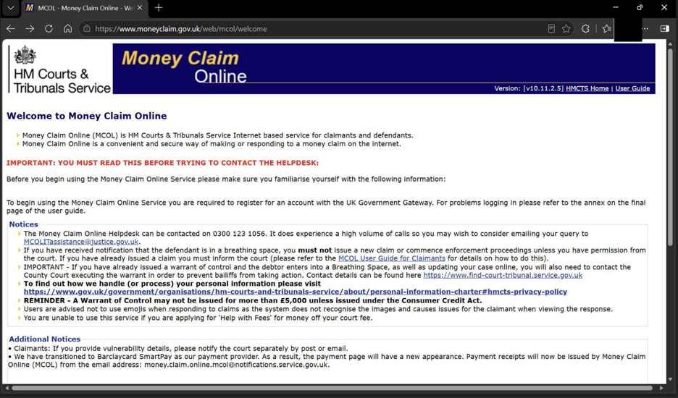

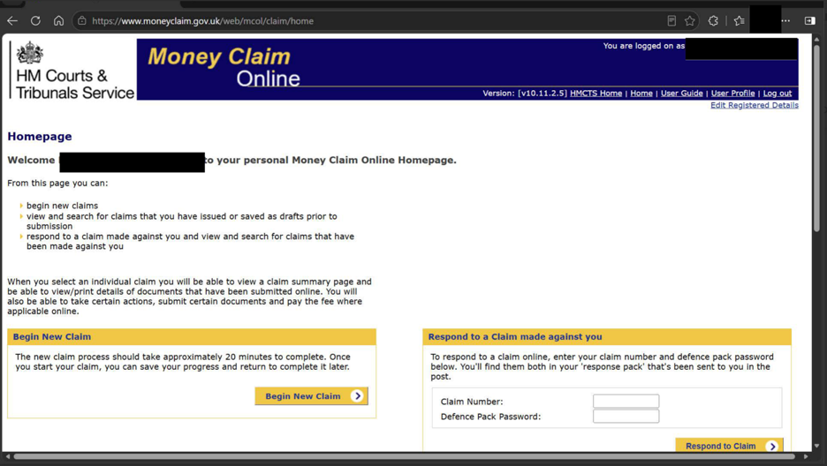
Step 1: Use the below link to Register or log into the portal.
Link: https://www.moneyclaim.gov.uk/web/mcol/welcome
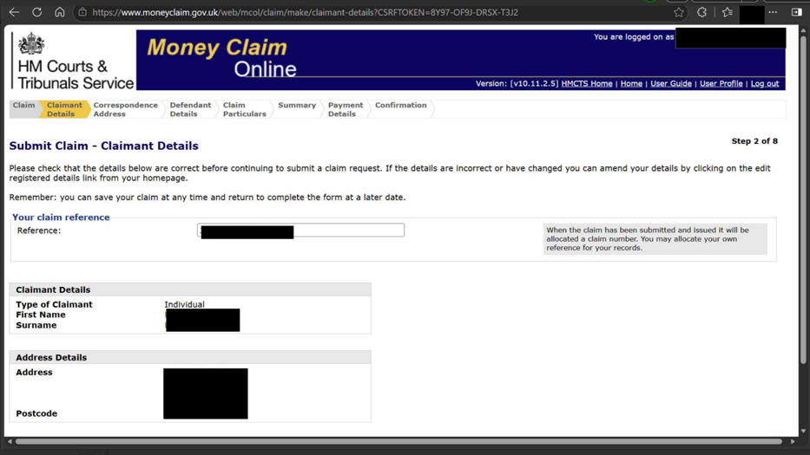
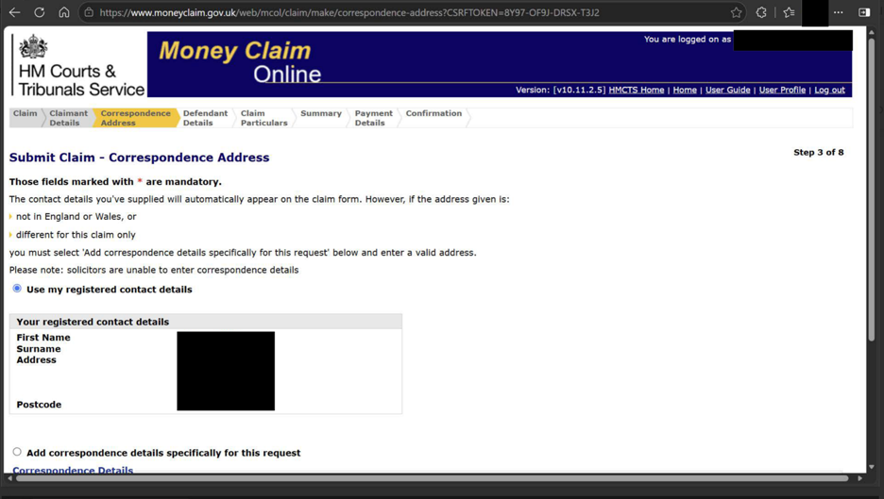
Step 2: Insert the Claimant’s details – are you bringing the claim individually (i.e., you are the owner of the website) or on behalf of the Company (i.e., the owner of the Website) you own/work for?
Make sure that the Claimant’s address for service is within the UK.
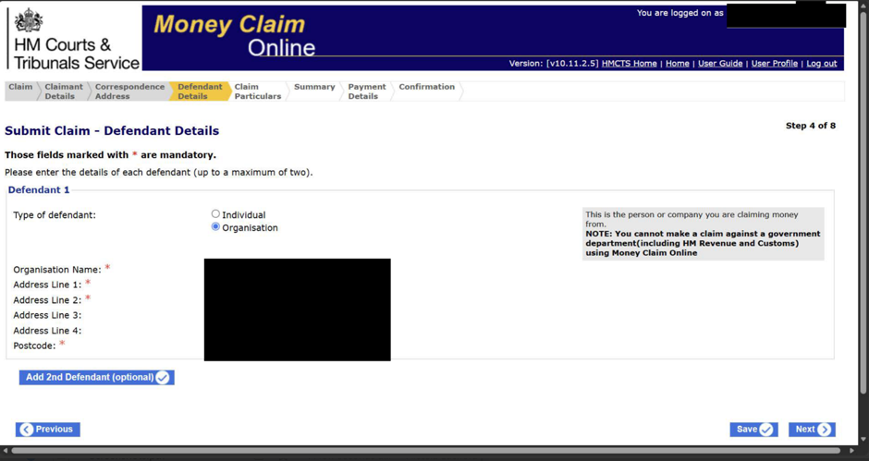

Step 3: insert the details of the Defendant(s). The Claim can only be brought through MCOL against a single defendant or a maximum of two defendants, and the Defendant’s address for service must be within England and Wales. Check against Companies House records to make sure you have the correct address of service.
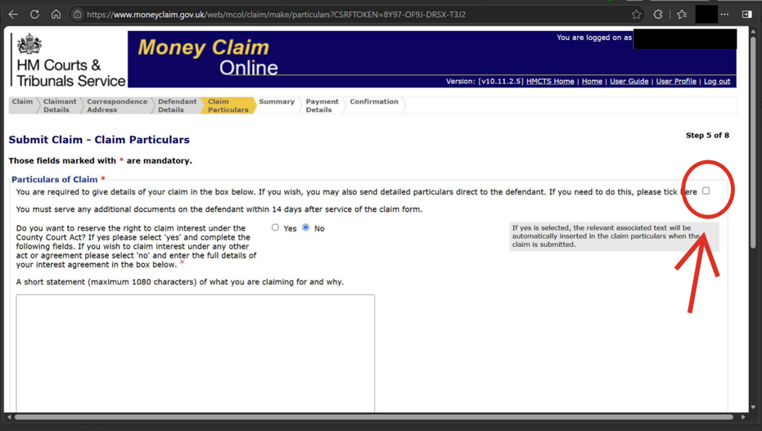
Step 4: You can include your Particulars of Claim in the online claim form, but there is a strict limit of 1,080 characters (including spaces). This may not give you enough space to properly particularise your claim. It is important that your claim is fully and clearly set out, as the Particulars of Claim form the basis of your case and will be signed and verified by a Statement of Truth. Any factual inaccuracies or omissions may undermine your case, and you may be prevented from relying on allegations or losses that have not been properly pleaded. In addition, signing a Statement of Truth without an honest belief in the truth of the contents may result in sanctions, including contempt of court proceedings.
If you intend to serve detailed Particulars of Claim separately, tick the box in the top right-hand corner (circled in red). You must still include a brief summary of the claim in the “Particulars of Claim” section and state that detailed Particulars of Claim will follow (see below for further details).
The detailed Particulars of Claim must then be served on the defendant and filed with the court separately in accordance with the relevant rules.
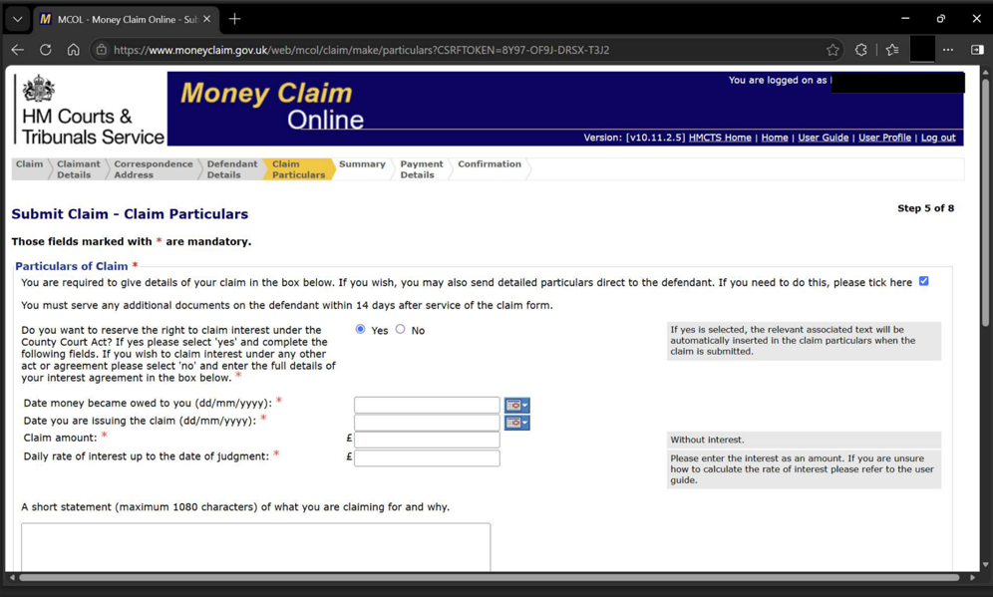
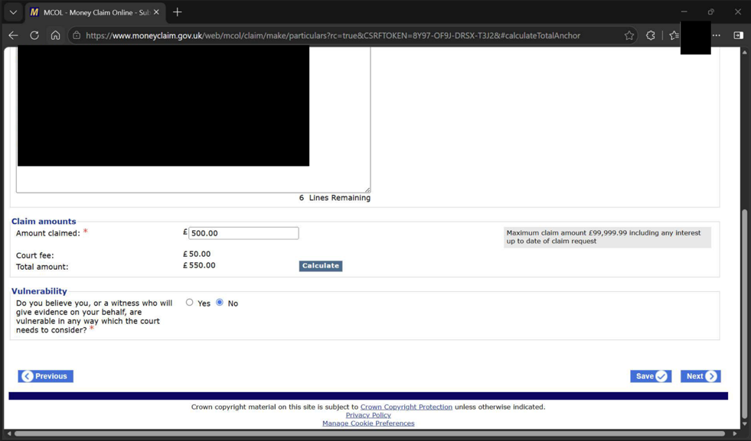
Step 5: The only remedy that can be sought through Money Claim Online is a specified sum of money, in pounds sterling, of less than £100,000 (excluding interest and costs) (PD 7C para 4.1).
If you wish to claim interest, tick the relevant box and the system will calculate it for you. Whilst interest is disregarded when assessing the value of the claim for track allocation, it will be included when calculating the court fee, so it will increase the fee payable.
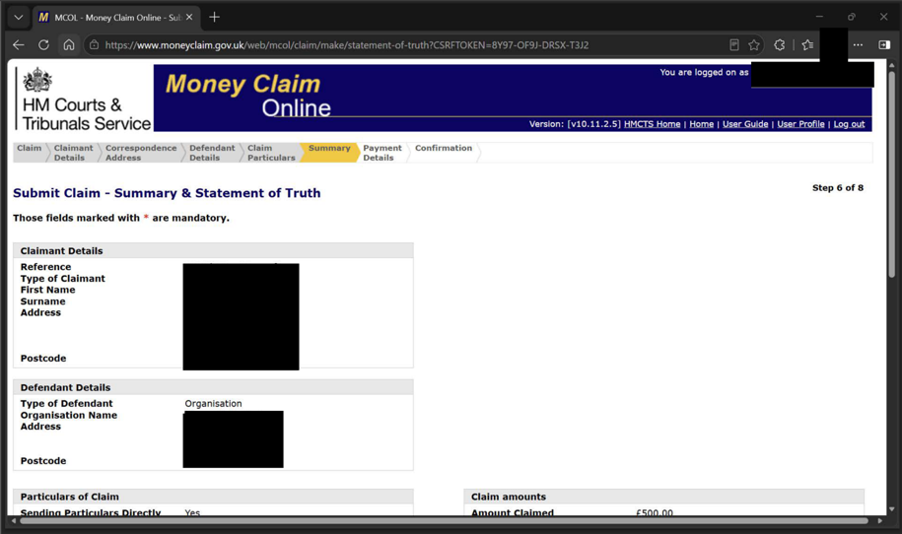
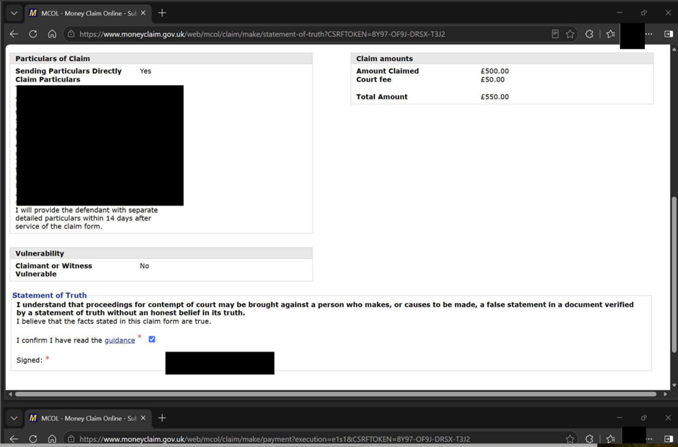
Step 6: Before you submit review the information you provided, carefully, as it will be verified by a Statement of Truth.

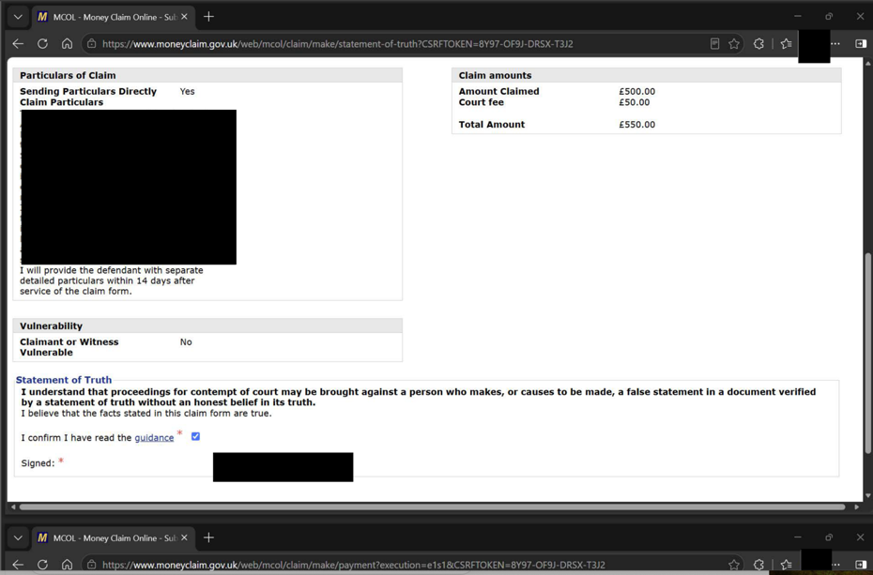
Step 7: You will need to pay the relevant fee based on the value of the claim usually by way of debit or credit card.
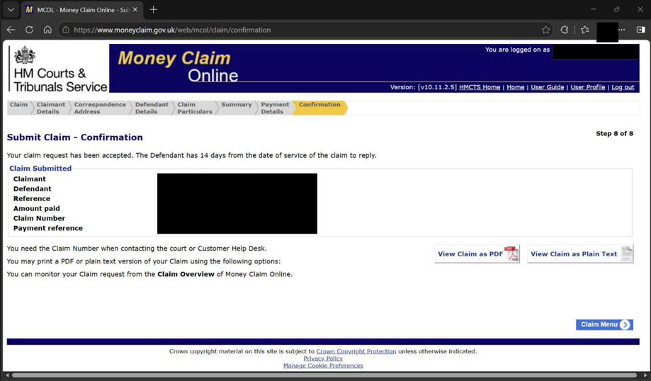
Step 8: Once you have completed the above step, your claim will be issued and the claim form will be available to download. An example of the Claim Form for MCOL can be found using the following link N1SDT Claim form.
If you do not wish to use MCOL, or your claim is not eligible (for example, because it is for £100,000 or more or is not for a specified sum of money), you should use the standard N1 claim form under CPR Part 7, available here: N1 Claim form (CPR Part 7).
Service of the Claim Form
At this point the claim has been issued but has not yet been “served” on the Defendant and so they will not know that a claim has been started. You can elect to serve the claim yourself but must request that the Court provide you with the documents that you will need to serve. If you do this then you will need to file a form to confirm when and how you have served the papers on the Defendant. Otherwise, the Court will serve the Claim Form and any documents in support as well as a Response Pack on the Defendant at the address for service within England and Wales that has been given for their address for service. [Money Claim Online (MCOL) user guide - GOV.UK]
Under PD 7C paragraph 5.5, when the court issues the claim, it serves a printed version of the claim form on the defendant and sends the claimant a notice of issue. The claim form is “deemed to be served on the fifth day after the claim was issued”, whether or not that day is a business day (paragraph 5.7).
Particulars of Claim
The Particulars of Claim must contain a concise statement of the material facts on which you rely (CPR 16.4(1)(a)). In a contractual claim, PD 16 paragraphs 7.3-7.5 require you to set out the contractual agreement relied upon, including whether it was written, oral or implied; identify the relevant contractual terms; and state by whom, when and where any oral agreement was made. A copy (or copies) of the contract or documents constituting the agreement should be attached to or served with the particulars of claim and the original(s) should be available at the hearing (PD 16 paragraphs 7.3(1)).
You should also state the remedy you are seeking from the court, such as damages, repayment of money, specific performance, or another form of relief, and include details of any interest claimed (CPR 16.4). In this case, the only remedy that can be sought under the MCOL is a specified amount of money (in Small Claims, less than 10,000 pounds excluding interest and costs claimed and in pounds sterling).
Where the Particulars of Claim are served separately from the Claim Form, they must include the name of the court, claim number, title of the proceedings, and the claimant's address for service (PD 16, para. 3.1).
The Particulars of Claim should be clear and well structured. Paragraphs should be numbered consecutively so that the court and the defendant can refer to them easily, and the pages should be numbered (see PD 5A). The document should be headed with the court, the parties and the claim number – for example:

IN THE CIVIL NATIONAL BUSINESS CENTRE Claim No.[]

BETWEEN:
[INSERT NAME OF CLAIMANT]
[(Company No. [Insert])]
Claimant
-and-
[INSERT NAME OF DEFENDANT]
(Company No. [Insert])
Defendant
_________________________

PARTICULARS OF CLAIM
_________________________

The Particulars of Claim must be verified by a statement of truth (CPR 22.1(1)(a)). The statement confirms the claimant’s belief that the facts stated are true, so the facts, allegations, contractual terms and losses relied upon should be set out clearly and accurately from the outset. The wording prescribed by PD 22 para 2.1 is:
“[I believe] [The Claimant believes] that the facts stated in these Particulars of Claim are true. [I understand] [The Claimant understands] that proceedings for contempt of court may be brought against anyone who makes, or causes to be made, a false statement in a document verified by a statement of truth without an honest belief in its truth.”
Service of Particulars of Claim
Where detailed Particulars of Claim are to follow, you must serve them on the defendant within 14 days after service of the claim form (CPR 7.4(1)(b); PD 7C para 6.1(1)), and in any event no later than four months after the date of issue (CPR 7.4(2) and 7.5). Under MCOL, the claim form is deemed served on the fifth day after issue (PD 7C para 5.7). The MCOL user guide advises serving them within 14 days of issue. To be safe, we recommend working to that earlier date.
When Particulars of Claim are served by first class post, they are deemed to be served, in accordance with CPR 6.26, the second day after posting, if that is a business day, or otherwise the next business day.
Certificate of service
After serving the Particulars of Claim, you must then file a certificate of service (form N215) at the Civil National Business Centre within 14 days of serving them (PD 7C paragraph 6.1). It can be emailed to ccbc@justice.gov.uk with the claim number in the subject line (PD 7C paragraph 6.2).
Although you are not required to file the Particulars of Claim unless the court orders it, we recommend filing a copy with the certificate of service so that the court has them on its file from the outset. If the claim is transferred to another court, you must file the Particulars of Claim there within 7 days of the notice of transfer (PD 7C paras 6.3 and 6.4).
(5) When to Defend a Claim
The Defendant will then have 14 days from the date of service to file an Acknowledgement of Service form (N9) which will acknowledge that they have received the form and inform of their intentions, including whether the Defendant wishes to admit or defend the claim. The Defendant may wish to serve a Defence at the time of the Acknowledgement of Service or, if not at that time, then they must serve the Defence within 28 days from the date they were served with the Particulars of Claim.
The Defendant may also use the Acknowledgement of Service form to contest jurisdiction, especially if they are located in a different country. However, if the Defendant does not file an application to dispute the jurisdiction of the court within 14 days of the date of filing this acknowledgment of service, the court will assume that the Defendant has accepted the court’s jurisdiction and that judgment may be entered against them.
If the Defendant files a Defence, the claim will proceed within the court process. If the Defendant does not respond or does not defend the claim in time, then it is open for you to apply for a judgment in default – a form that confirms that the defendant has been served with the proceedings but has not responded or responded within the time required. A default judgment enables enforcement proceedings to be instigated against the defendant.
In a MCOL claim for a specified debt, a request for judgment in default may be made online and the judgment will ordinarily be entered by a court officer without the need for a hearing (CPR r.12.4(1)).
However, a Defendant may subsequently apply to set aside a default judgment if they satisfy the court that there is a real prospect of successfully defending the claim, or that there is some other good reason for the judgment to be set aside (CPR r.13.3). Claimants should be aware that default judgment does not guarantee final recovery — it is the first step in enforcement, not the last.
(6) Steps to Trial
Directions Questionnaire
Once the Defence has been filed, the parties will receive a Notice of Proposed Allocation, with the Directions Questionnaire (the N180 Form for Small Claims) from the court. The deadline to file with the court and serve the Directions Questionnaire on the Defendant will be set in the Notice of Proposed Allocation.
The purpose of the questionnaire is to evaluate the factors surrounding the complexity of the claim so that it can be allocated to a track by a District Judge. For this reason, it is important to keep the claim as simple as possible to have it allocated to the Small Claims track.
In this form, you will be asked to provide details including:
- the number of witnesses you intend to rely upon;
- the estimated length of the hearing (which, for small claims, is typically no more than two hours);
- whether you consider expert evidence necessary;
- whether you would prefer the matter to be determined at an oral hearing or on the papers; and
- which hearing venue you would like the case to be listed at.
As a general rule, parties should seek to keep the number of witnesses to a minimum and avoid the use of expert evidence where possible, as this helps ensure that the dispute remains suitable for allocation to the Small Claims Track. You should ordinarily request the county court most convenient to you, although the court may also take into account the location of the defendant and other relevant factors.
The Directions Questionnaire will also require you to provide information relating to the mandatory Mediation, discussed below. You should complete this section carefully. The court expressly warns that a failure to complete this section may result in sanctions for non-attendance.
Reply
At this stage, you may also wish to file a Reply to matters raised in the Defence and, where applicable, a Defence to any Counterclaim. Unlike the Particulars of Claim and the Defence, the Reply is an optional statement of case, and will not be necessary in small claims where issues are straightforward. It enables the Claimant to address new factual allegations, or other matters raised by the defendant which require clarification, and must be filed with the Directions Questionnaire (CPR 15.8). Careful consideration should therefore be given as to whether any issues raised in the Defence ought to be addressed at this stage, as the Reply represents the final opportunity to plead your position before allocation without first obtaining the court's permission (CPR 15.9).

Importantly, If the Defendant has brought a counterclaim, you must file a Defence, and as such this be done with the Reply as per CPR 15.8(b)).

Mediation
Mandatory mediation applies automatically to all defended Small Claims Track cases where the claim value does not exceed £10,000. Parties do not need to consent to mediation — it is an automatic and compulsory step in the process. Once the case has been allocated to the Small Claims Track, the court will refer the matter to the HMCTS Small Claims Mediation Service. The parties will be contacted by HMCTS to arrange a mediation appointment, which is a telephone-based session typically lasting up to one hour and conducted by a trained HMCTS mediator.
Mediation is confidential: nothing said during the mediation may be referred to at any subsequent hearing. If the mediation is successful and the parties reach a settlement, a settlement agreement is drawn up and the court claim is stayed. Either party may apply to lift the stay if the settlement terms are not complied with.
If a party fails to engage with the mandatory mediation process without reasonable excuse, the court may take this into account when exercising its discretion on costs (CPR r.27.14(2)(g)), even within the Small Claims Track where costs are generally not recoverable.
Standard Directions
If the matter does not settle through mediation, the claim will proceed pursuant to directions given by the court. The court will look at the time estimates provided in the Directions Questionnaire and the nature of the claims in the Particulars of Claim and defence and will provide a hearing date giving at least 21 days notice, though in practice hearing dates are typically listed several weeks or months in advance depending on court availability. Directions for the hearing will be given: standard directions usually comprise a date and time listed for the hearing and instruct the parties to file and serve all of the documents that they will be relying upon at least 14 days prior to the hearing. This will include the Letter Before Claim and any reply to it – underlining the importance of these documents. There is also usually a prohibition on any expert evidence to be adduced except with the approval of the court.
Special Directions
The court retains discretion to add to the directions, and may even decide to dispose of the matter without a hearing. Accordingly, the statements of case and Directions Questionnaires are important because the dispute may be decided upon by the court on the documents alone. Special Directions may include:
A direction for a party to further clarify their statement of case.
A direction that each of the witnesses that are to give evidence at the hearing file and serve Witness Statements setting out their evidence signed in each case with a statement of truth.
A direction that Expert evidence on a particular issue be allowed – usually an expert that is to be instructed jointly and to produce an expert’s report for the benefit of the court. The fee limited for such an expert is 750 pounds.
Hearing
Usually half a day is allocated (about 2.5 hours).
Small claims will generally be held in public. The hearing may be held in the Judge’s room or in court.
All communications between a party and the court must be disclosed, and written communications must be copied to all other parties.
Small claims hearings will be recorded, and transcripts can be obtained on payment of a transcriber’s fee.
Strict rules of evidence do not apply to small claims. Judges will control the procedure. The court need not take evidence on oath and may limit cross examination. Documents signed with a statement of truth can be used as evidence in the hearing (even if a party does not appear).
The court must provide reasons for its decision. Judges may give their judgment orally as briefly and as simply as the nature of the case allows. Where a judge decides the case without a hearing, he will prepare a note of his reasons and send a copy to each party.
The claimant will need to pay a trial (hearing) fee under fee 2.1 of Schedule 1 to the Civil Proceedings Fees Order 2008 (CPR r.3.7A1(1)(d)), which on the small claims track ranges from £27 to £346 depending on the value of the claim.
Recoverable Costs
These are usually limited to the amounts that you have paid out in court and other fees (for example if an expert has been involved in a claim). There is provision for additional costs to be awarded if a party has acted unreasonably in all the circumstances – this includes, for example, not complying with mediation or other Alternative Dispute Resolution.
Discontinuing a Claim
If you discontinue your claim, you will usually have to pay the defendant’s costs incurred up to the date you served the notice of discontinuance (CPR 38.6(1)). This rule does not apply once a claim has been allocated to the small claims track (CPR 38.6(3)).
If you discontinue before allocation, the general rule applies. However, when assessing those costs, the court may limit them to what would have been allowed on the track the claim would have been allocated to (CPR 46.13(3)). If your claim would likely have been allocated to the small claims track, you can therefore argue that the defendant should recover only the limited costs available on that track. The court decides this, so the outcome is not guaranteed.
(7) Appeals and Enforcement
Appeals
These will depend on the judge that has heard the case. Appeals are usually made from a District Judge to a Circuit Judge. Permission to appeal is required and should first be sought orally from the District Judge at the conclusion of the hearing. If permission is refused or not sought at the hearing, the Appellant must file an Appellant's Notice (N164 - Appellant's notice (Small Claims Track only) at the relevant County Court hearing centre within 21 days of the date of the decision being appealed. Strict time limits apply.
Enforcement
Once judgment has been obtained, the Claimant can demand that the monies are paid by the defendant in accordance with the order of the court, failing which enforcement proceedings can be progressed. See section Enforce a Judgment in the Make a Court Claim for Money document referred to above.

